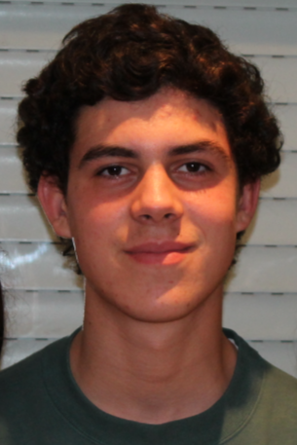

**RODRIGO SARROEIRA**

19 years old (21.12.2001)

Lisbon

**Mail:** rcdfs@iscte-iul.pt

**Mobile:** 916 724 141

**Linkedin**: https://www.linkedin.com/in/rodrigo-sarroeira-391955193/

**ACADEMIC QUALIFICATIONS:**

12º Degree

Area: Economic Science

Liceu Camões, Lisbon

From: September 2017 To: July 2019

Average Grade: 15, 3

2nd year – Graduation’s degree on Data Science

ISCTE – Instituto Universitário de Lisboa

Starting Date: September 2019

Average Grade: 16, 3 (until now)

___________________________________________________________________

**MAIN SUBJECTS:**

Maths, programming, Algorithms and Data Structures, Machine Learning,

Supervized Methods.

**COMPUTER SKILLS:**

* Python and R;
* SQL;
* HTML and CSS;
* Outsystems;

**CERTIFICATES:**

Outsystems Masterclass (40 Hours)

Cambridge FIRST Certificate in ESOL International – Grade B; October 2017

**LANGUAGES:**

* **Portuguese:** Mother tongue
* **English:** Good

**HOBBIES:**

* Playing classical guitar, piano and Reading

**VOLUNTEERING:**

* Fruta Feia, Campo de Santa Clara

**Project:** https://frutafeia.pt/

**Goal:** Help small farm productors